Assignment 8 Reflection:

All of the requirements for Assignment 8 are complete.

I didn’t have any struggles in the execution of this program. However, it did take some time to decide how to print the standings of players per round, and how to handle the case when there was a winner. In that case, I had another while loop that finished printing the standings of the round, without having the players take a final turn as a winner was already found.

**RemoveAllTest.java (LinkedSortedList)**

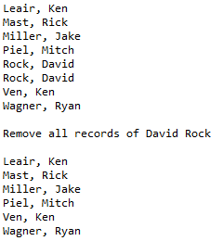

**RemoveAllTest.java (ArraySortedList)**

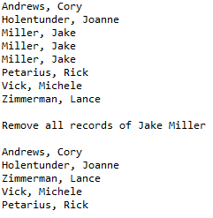

**Race.java**

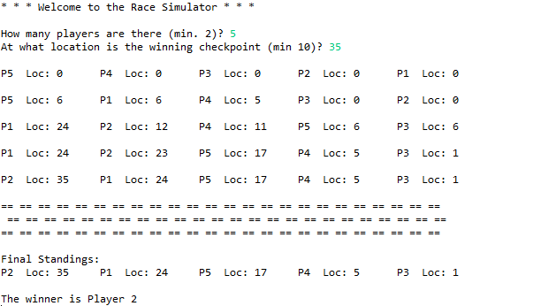

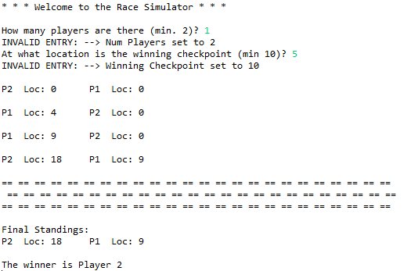

|  |  |  |  |  |  |  |  |  |  |
| --- | --- | --- | --- | --- | --- | --- | --- | --- | --- |
| numPlayers | |  |  | | --- | --- | | Test Value | Outcome | | -5 | 2 | | 1 | 2 | | 5 | 5 | |
| maxPosition | |  |  | | --- | --- | | Test Value | Outcome | | -5 | 15 | | 10 | 15 | | 25 | 25 | |

* The two values that could be modified by user entry were numPlayers and maxPosition (Winning Checkpoint)
  + numPlayers
    - The minimum value for numPlayers is 2, if a value entered was less than 2, the minimum value was defaulted to 2
  + maxPosition
    - The minimum maxPosition(Winning Checkpoint) is 15. If a value entered was less than 15, the maxPosition was defaulted to 15.